 | CANDIDATE INFORMATION FORM

POSITION APPLIED FOR: java developer
Total Experience: 1year 10month

PERSONAL INFORMATION
First Name Middle Name Last Name
Asadullah
Current Address. Wajid ali compound 90 fit road sakinaka, Andheri east
, 400072 Mumbai MH
Permanent Address. Aata kala post,pachpokhari bazar, dist. Sant Kabir nagar ,UP 272125

Mobile Nos -7458872341

Name & Contact Details in Case of Emergency -father name -Sharifullah, 9839443065

Email ID - asadjit77@gmail.com
Date of Birth - 12/03/2001
Marital Status - unmarried

Source of Application:-

A. Call from Saksoft Ltd (Name of the caller)____Mumtaj shaikh___________________________________
B. Reference (by Saksoft
Employee) _______________________________________________
C. Consultant’s Name________________________________________________________

EDUCATION QUALIFICATION

(Begin with most recent qualification and end with Std XII)

Course/Degree | Year Of  Passing | Specialization | Institute/University | Aggregate % or CGPA
BCA | 2021 | COMP. APP | Pune university | 70
12th | 2018 | Science | UPboard | 73

WORK EXPERIENCE

Employment Details till date

Name of the organization | Location | Designation | Duration
Name of the organization | Location | Designation | From | To
Probity virtue it solution pvt.ltd | Pune | Java developer | 10-aug-2020 | 12-oct-2021
Mosambee(synergistic financial network pvt.ld) | Mumbai | Java developer | 13-oct-2021 | Till now

CURRENT SALARY DETAILS

Current Employer Name: |  |  |  | Designation :
CTC: 4,50,000 Take Home (monthly) : 31,186.00 Variable Pay :20,000.00
Enter monthly details for:
Basic: 17917 | HRA:  8958 | Conveyance: | Special Allowance:  5728 |  | Reimbursements: | Bonus:  583
Expected Annual Gross:  1,00,000.00+ |  |  | Official Notice Period:  Can join in (no. of days) :within a week

REFERENCES
Give references under whom you have either worked or who know you professionally.
No. | Name | Duration & Nature of  Association | Organization & Designation | e-mail | Phone
 | Anas Ahmad | Soft.eng. | datamatics as java developer | Anasahmad9161@gmil.com | 9967821143

WORK LOCATION
Are you willing to be posted in Pune? yes | Are you willing to be posted abroad? yes
Current Visa status : No

I hereby declare that my statements on this application and on my resume or documents provided by me are correct to the best of my knowledge. I acknowledge and agree that providing any false information may result in a decision not to hire me or if hired, may result in termination of my employment.

Date: 16/06/2022 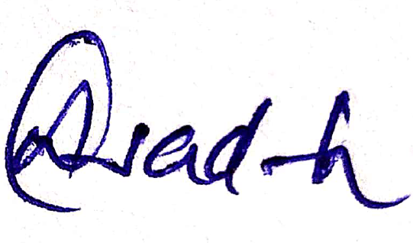
Place: Mumbai Signature:
*Confidential when completed*

